Hope or Hype:

Can AI Boost Human Capital in the Global South?
Gabriel Demombynes

August 15, 2025

Rapid developments in artificial intelligence have generated hopes that the technology may help overcome the massive gaps in human capital—education, skills, and health—in the developing world. While attention has focused principally on using as a direct substitute for service providers, emerging evidence suggests that the greater potential is in using AI to augment or supplement frontline workers. We review the thin but growing evidence on AI’s promise for developing countries and highlight its many potential perils. Like previous technologies, implementing AI solutions on the ground relies on a wide set of enabling factors including infrastructure, human capital, and institutions. Scarcity of these factors will almost certainly limit the pace of AI’s adoption in many low- and middle-income countries. Much more research is needed to better understand how AI can be used effectively in the face of such constraints.

Abstract:
JEL classification:
Keywords: Human Capital, Artificial Intelligence

1. Introduction

The human development gaps between rich and poor nations are immense. Roughly 7 out of 10 children in low- and middle-income countries are unable to read and understand a simple text by age 10. Four and a half billion people worldwide lack access to essential health services. Could artificial intelligence help lift up the Global South’s human capital and thus provide a boost to economic development and cut global poverty?

There are reasons to be optimistic about the promise of AI for human development. The first is the ever-growing power of the technology itself. [Find quotes]. The second is the apparently high level access. Access to many generative AI tools is available at no cost to anyone with a mobile phone and an internet connection.

There are other reasons for skepticism. Previous waves of technology have often failed to deliver on hoped-for results in human development. In the realm of education technology, for example, the One Laptop per Child initiative is the classic example of a failed technological material. Launched 20 years ago attempted to transform education through access to devices and software, but rigorous evaluations found the program had zero impact on educational outcomes. The basic lesson from OLPC was that technology by itself it not enough. And like technology more generally, tech for education and health has had only limited diffusion to many developing countries.

Additionally, artificial intelligence poses a number of potential perils, some of which are associated with digital technology generally and others which are specific to AI. These include negative impact of extensively using digital devices, as well as bad information from AI, the misuse of data collected by AI, and bias in AI results.

This paper considers both the promise and peril of AI for education and health in Global South, reviewing the literature from rigorous studies that have been conducted in developing country contexts. The review focuses on studies that use randomized controlled trials or other approaches that identify causal effects. It includes published research studies, working papers, preprints.

Finally, a note on terminology and scope: the broad term artificial intelligence coined by John McCarthy in 1955 was defined originally as “the science and engineering of making intelligent machines.” A variety of other definitions have emphasized particular capabilities, including learning, reasoning, problem-solving, decision-making, perception, and variability. Machine learning (ML) is one aspect of AI that uses algorithms to learn from and make predictions based on data. Generative AI (GenAI) is a branch of machine learning that creates new content, using patterns and relationships it identifies based on training data. Large language models (LLM) are a subset of GenAI that works with text.

2. Conceptual Framework: How AI Can Accelerate Human Capital in LMICs (≈2 pp)

In broad terms, AI could potentially be used through two different modalities to improve human development in LMICs.
The first is through direct service provision to clients via AI tools. Examples include student tutoring, mental health therapy, and direct-to-patient medical advice. In these cases, provision via AI substitutes for health workers and teachers. These applications have dominated much more popular discourse on AI’s potential. See, for example, the influential book on AI by Suleyman (2023). [Note other books?]
A second potential channel for AI to improve service delivery is by augmenting the skills of health and education workers. In such applications, AI can provide information, diagnostics, ideas, or materials to be used by the workers themselves. This modality keeps “humans in the loop” and thus involves judgment by the workers as to the usefulness and applicability of information supplied by the AI.
There is some overlap in these two modalities. For example, AI tutors have be used in a classroom with supervision by teacher, and AI therapists could be used with direction and monitoring by mental health professionals.
Regardless of the approach, implementation of AI solutions requires the presence of a series of enabling (or complementary) factors. This observation is specific to technology for human development but also reflects the broader experience with technology adoption in developing countries (Cirera et al 2022). A partial list of enabling factors for artificial intelligence applications in LMICs includes the following:

[Explain WHY a special focus on developing countries?]

Electricity. Electricity is clearly the first building block for use of AI. While electrification has expanded rapidly—particularly in India in recent year—across sub-Saharan Africa, half of households still do not have electricity. Even where grid connections are available, provision may be unreliable or prohibitively expensive. Rates of access in schools and health center facilities can be even lower. Figure X shows some figures from the fragmentary available data. Just 86% of hospitals in Latin America and the Caribbean, and 50 percent of those in sub-Saharan Africa have reliable access to electricity https://www.who.int/data/gho/data/themes/database-on-electrification-of-health-care-facilities (World Health Organization, World Bank, International Renewable Energy Agency & Sustainable Energy for All ‎2023). Rates for non-hospital facilities and those in rural areas are lower. Very few primary schools have electricity in many countries: 4% in Chad, 10% in Democratic Republic of Congo, 11% in Madagascar (UNESCO Institute for Statistics, 2023 data.) Reported rates of access are higher in lower secondary schools (23%, 12%, and 49%, respectively for Chad, DRC, and Madagascar.)

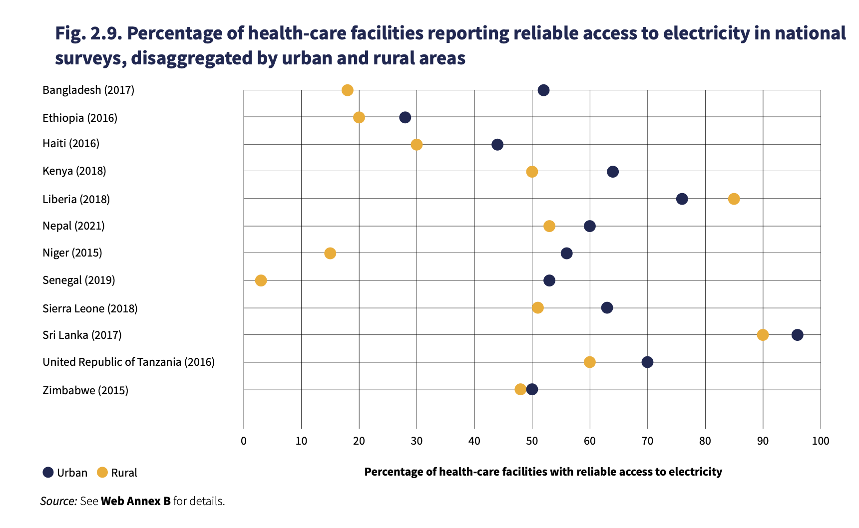
- https://www.who.int/data/gho/data/themes/database-on-electrification-of-health-care-facilities (World Health Organization, World Bank, International Renewable Energy Agency & Sustainable Energy for All ‎2023).

Share of primary schools with access to electricity
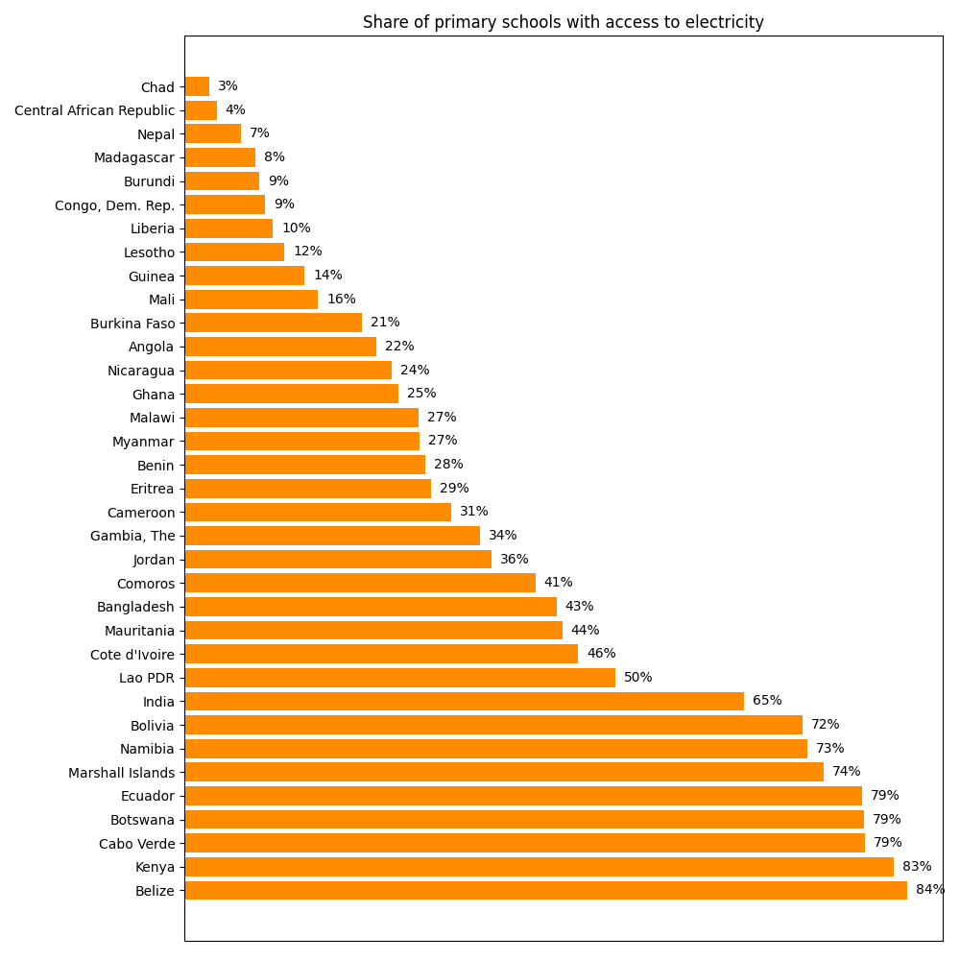
Source: UNESCO Institute for Statistics
Note: Data shown are for most recent year available. Shown are all low- and middle-income countries with access rates below 90 percent. Countries with available data and rates above 90 percent are the following: Albania, Argentina, Armenia, Azerbaijan, Belarus, Bhutan, Brazil, China, Colombia, Cuba, Djibouti, Dominica, Egypt (Arab Rep.), El Salvador, Eswatini, Fiji, Georgia, Grenada, Honduras, Indonesia, Iran (Islamic Rep.), Jamaica, Kazakhstan, Kyrgyz Republic, Lebanon, Malaysia, Maldives, Mauritius, Moldova, and Morocco

Internet access. Although access to the internet through mobile networks has exploded, connections in some places, particularly rural areas, remain spotty. The cost of data limits actual usage. Consistent access to broadband by health and education facilities is limited in many countries, though there is no unified data on facility access.

[Figure on Internet access.]

Devices. Cheap smartphones have become widely available, allowing some access to the Internet for those with a place to charge them and the means to pay for data. Nonetheless, access to laptops remains a limitation for applications that require them.

[Figure on device ownership]

Expertise. Various levels of “digital skills” are needed to use and implement AI effectively. For individual use, in addition to basic facility with the device, the user needs to be able to acquire the ability to use the particular application. For widespread use in a facility setting with personal computers, someone at the facility needs to understand how to install and maintain software, as well as design and implement its use by students and patients.

Institutions. Beyond the enabling factors defined above, there is a more nebulous set which falls under the heading of “institutions.” This encompasses the regulatory and administrative capacity and incentive structure of government to do everything else necessary to effectively implement an AI solution in practice. Elements of this process include decisions to implement an AI application, procurement to acquire the needed hardware and software, and a system that can implement its use, resolve problems that emerge, and make adjustments as needed.

3. Evidence on the Promise of Human Development Applications in the Global South
This section reviews the studies that have been conducted in developing countries, highlighting broadly applicable lessons. It focuses heavily on published studies—including working papers and pre-prints and particularly those with designs that can identify causal effects.
Education
A number of global systematic reviews have examined the impact of artificial
intelligence on student learning via the use of GenAI as a learning assistant or personal tutor (following the direct-to-student modality described in the previous section). Four different reviews consider the impacts specifically of ChatGPT (Deng et al. 2024; Wang and Fan 2025; Deng et al. 2024; Munaye et al. 2025.) Those studies find that most of the published literature on ChatGPT and learning has examined in applications in higher education. As a whole, they find large impacts on learning. (Wang and Fan 2025) estimates an overall standardized effects size of 0.867 on learning performance across 51 experimental and quasi-experimental studies.

The discussion here distinguishes between pre-GenAI machine learning applications and GenAI. Many pre-GenAI adaptive learning applications have demonstrated impacts on learning [reference highlight, based on background paper]. These involve applications which use machine learning to adapt to student needs based on their performance with the application. We focus on GenAI. Just three published studies have examined the use of GenAI for education in low- and middle-income contexts(De Simone et al. 2025; Henkel et al. 2024; Choi et al. 2024). These are discussed below.

[Consider adding table with points on enabling factors and country-level conditions]

The first study is a pre-print descriptive analysis from provision of an AI chatbot to teachers in Sierra Leone (Choi et al. 2024) Over a period of 17 months, they were provided with theTeacher.AI, a WhatsApp interact to OpenAI prompted as an education assistant. The system was tailored to provide evidence-based guidance on pedagogy, to follow safeguards, to only answer education-related questions, and provide answers appropriate to a low-resource setting. Rather than study the impact of the teachers’ AI usage, the researchers carefully examined how the teachers used the tool. They found that the main use (69 percent of queries) were for facts and concept clarification, which they note non-AI web searches could be expected to effectively answer. The study suggests that a main advantage of the AI tool using WhatsApp is that it provides information similar to what a web search would yield, but at much lower cost.

The second study concerns a simple AI tutor experiment in Ghana, for which a preliminary evaluation has been published in pre-print form (Henkel et al. 2024.) Researchers evaluated “Rori,” which delivered chatbot-like assistance via WhatsApp on mobile phones. In this 8-month 2023–24 trial, ~1,000 students (grades 3–9 across 11 schools) received two 30-minute Rori tutoring sessions per week in addition to regular math classes. The results from a randomized control trial showed markedly higher math scores for the AI group, with an effect size of about 0.36 SD after one school year. A notable aspect of the pilot is that the tutoring was delivered using minimal technology – basic Android phones on 2G/3G networks – and thus was less demanding in terms of enabling factors than other AI applications. However, the pilot was conducted in schools of Rising Academies, a low-cost private school network, which provided an institutional structure for implementation than would generally be available in public schools.

The third study is a small-scale pilot with a randomized control pilot was conducted by World Bank researchers in Edo State in Nigeria (De Simone et al. 20250. They tested a six-week after-school program where first year secondary-school students used Microsoft Copilot on laptops (GPT-4) as a guided English tutor. The study reports 0.23 SD gains in English and gains of 0.31 SD across a composite that adds AI/digital skills (calculated as intent-to-treat effects).

The Nigeria study illustrates the importance of several enabling factors. First, all schools selected for the study had electricity access. Second, as part of the intervention, internet access was provided through mobile routers. Third, laptops from a World Bank surplus equipment program were provided to the participating schools. Fourth, the intervention provided training to the teachers who supervised. Fifth, the intervention managed data and instructional support, IT support, and overall program management. According to 2022 government figures, among public junior secondary schools in Nigeria, 47% of (6,509 of 13,921) have electricity and 31% (4,303 of 13,921) have computers. Internet access and the other complementary factors would not typically be available at other public schools in Nigeria.

https://ubec.gov.ng/wp-content/uploads/2024/04/2022-Digest-of-Public-Schools.pdf

[List other ongoing studies, including support to teachers!!]

Health

Artificial intelligence has raised high hopes it may improve health care delivery in LMICs. [Ciecierski-Holmes] As with education, evidence on the effectiveness of AI systems in real-world practice settings is limited. This section reviews published evidence two forms of support to health workers—general clinical decision support and medical imaging interpretation. It also Many of these papers are also pre-prints or working papers.
Many studies have shown that LLMs can out-perform physicians in medical qualification exams and benchmark tests which simulate clinical situations (Goh et al., 2025; Arora et al., 2025; Nori et al., 2025; Van Veen et al., 2024). However, actual use of AI in real-world clinical settings with careful evaluation has been highly limited.
The one existing study in this vein, published as a pre-print, reviews the implementation of an AI clinical support tool in 15 primary care clinics operated by the Penda Health network in Nairobi, Kenya (Korom et al. 2025). The tool, AI Consult, is integrated with electronic workflows for health workers and flags potential documentation and clinical errors in real-time. The study compared diagnostic and treatment decisions between physicians who had access to AI Consult to those who did not. Overall, the study found that AI Consult had a positive impact on the quality of care, with fewer errors made by those who used AI Consult. Those using the tool made 16% fewer diagnostic errors and 13% fewer treatment errors. Additionally, when surveyed afterwards, those who used AI Consult universally said it improved the quality of their care.
The AI Consult study provides the first solid evidence that clinical support in an LMIC setting can improve the quality of care. One caveat is that errors were identified by independent physician evaluators reviewing the clinical decisions, and those evaluators often disagreed among themselves as to what were correct decisions. This is reminder of the challenge of evaluating the quality of care in real-world settings where patients sometimes present complex cases. A more critical question is to the extent to which the findings from this study are more broadly applicable in other LMIC settings. The Penda Health network is a for-profit social enterprise, which likely means it has a much stronger adminstrative support structure than is typically found in public health facilities—which dominate health care (especially primary care) in many LMICs. Consequently, the Penda facilities were able to rapidly adopt new technology. Notably, it was possible to integrate AI Consult because Penda had adopted full use of electronic medical records (EMR) in 2017 and already employed pre-AI rule-based guidance to physicians through the EMR system. In many LMIC facilities elsewhere, use of EMR remains partial or nonexistent.
Medical imaging:

Direct-to-patient medical guidance

AI Applications in Diagnostics and Clinical Decision Support
One of the most active areas is AI for clinical diagnosis and decision support. Many studies evaluate AI’s ability to equal or surpass clinicians in detecting diseases, often using medical imaging or clinical data. In medical imaging, AI systems have shown high accuracy in LMIC settings. For example, an AI deep learning model for diabetic retinopathy (DR) screening was validated on retinal images from African populations, achieving high sensitivity and specificity for referable DRpubmed.ncbi.nlm.nih.govpubmed.ncbi.nlm.nih.gov. In Thailand’s national DR screening program, a prospective study integrated a deep-learning system at multiple primary care clinics; the AI’s sensitivity (~91%) and specificity (~95%) for vision-threatening DR were comparable to retina specialists, enabling real-time screening without onsite ophthalmologistspubmed.ncbi.nlm.nih.govpubmed.ncbi.nlm.nih.gov. Similarly, in China, an AI system that analyzes pediatric clinical records was able to diagnose common childhood diseases at an accuracy level comparable to experienced pediatricianspubmed.ncbi.nlm.nih.govd-nb.info. These results demonstrate AI’s potential to fill diagnostic gaps in LMICs by scaling expert-level interpretation of images and clinical data.
Rigorous evaluations of AI in diagnostics are beginning to emerge. In tuberculosis (TB) care, the PROSPECT trial in Malawi (a three-arm randomized trial) tested an AI-assisted chest X-ray screening tool (CAD4TB) for adults with TB symptomsjournals.plos.orgjournals.plos.org. Integrating AI X-ray screening (alongside routine HIV testing) significantly improved TB case detection and treatment initiation: 3.0% of patients in the AI screening arm started TB treatment within 56 days versus 1.1% under standard care, and the median time to treatment dropped from 11 days to 1 dayjournals.plos.orgjournals.plos.org. This AI-driven approach also increased same-day TB treatment and reduced the fraction of undiagnosed TB and HIV casesjournals.plos.orgjournals.plos.org. However, the cost-effectiveness was mixed – while life-saving, the AI intervention was not cost-effective in the short 2-month horizon, highlighting the need for longer-term and scalability analysesjournals.plos.orgjournals.plos.org.
In cancer diagnostics, AI has been applied to expand access to early detection. A field study in Mexico showed that a portable ultrasound with AI-based computer-aided diagnosis could be used by minimally trained health workers to triage breast lumps, correctly distinguishing suspicious masses for referralascopubs.orgpubmed.ncbi.nlm.nih.gov. The AI-assisted ultrasound system achieved high acceptability, suggesting a feasible approach to improve breast cancer screening where specialists are scarce. In China, AI decision-support systems have been piloted in oncology: one study compared IBM’s Watson for Oncology recommendations to actual treatment decisions for 362 cancer patients. Concordance was high for some cancers (e.g. 80%+ in breast and lung cancer) but much lower for others (only 12% in gastric cancer), revealing where the AI’s suggested regimens diverged from local standard of carepmc.ncbi.nlm.nih.govpmc.ncbi.nlm.nih.gov. The overall concordance study underscored that AI tools trained on protocols from high-income settings may need localization to reflect epidemiological and practice differences in LMICspmc.ncbi.nlm.nih.govpmc.ncbi.nlm.nih.gov.
AI-powered clinical decision support systems (CDSS) and triage tools are also being deployed. For instance, an AI-driven diagnostic assistance system (the “Brilliant AI Doctor”) was implemented in rural primary care clinics in Chinad-nb.info. Case studies reported that while the tool could improve the consistency of care, there were challenges integrating it into workflows and earning clinicians’ trustd-nb.infod-nb.info. In Bangladesh and Rwanda, AI-based triage chatbots (e.g. symptom checkers on mobile apps) have been introduced to guide patients on seeking care. A study of an AI health chatbot in a real-world setting found moderate user engagement – thousands of self-assessments were completed – but also noted issues of reliability and safety, as some chatbot advice did not perfectly align with clinical guidelinesd-nb.infod-nb.info. Overall, AI decision aids show promise to support overstretched clinicians and empower patients, but rigorous evidence of their impact on diagnosis accuracy and clinical outcomes remains limited.

AI in Public Health and Disease Surveillance
Beyond individual patient care, AI is being applied to public health surveillance and epidemic intelligence in LMICs. A number of recent studies have developed AI-based early warning systems (EWS) that ingest diverse data sources – epidemiological reports, online news, climate data, even wastewater signals – to predict disease outbreaksfrontiersin.orgfrontiersin.org. These AI-driven surveillance models have demonstrated the ability to detect outbreaks earlier and with improved predictive accuracy for diseases such as dengue fever and malaria, compared to traditional methodsfrontiersin.orgfrontiersin.org. For example, machine learning models using climate and mosquito data in Southeast Asia have successfully forecasted dengue incidence several weeks in advance, allowing targeted public health interventions. During the COVID-19 pandemic, some LMIC governments and researchers leveraged AI to track epidemiological trends: by mining social media and search trends with natural language processing, AI systems provided real-time situational awareness of COVID-19 spread where formal reporting was slowfrontiersin.orgfrontiersin.org. These approaches illustrated AI’s potential to strengthen disease surveillance networks in resource-constrained settings by compensating for gaps in human reporting capacity.
However, rigorous evaluations of AI-based surveillance are scarce – most studies are observational or predictive modeling exercises. Reported benefits include faster detection of outbreaks and granular hotspot mappingfrontiersin.org, but few demonstrate impact on actual public health outcomes (e.g. reduced cases or mortality) via experimental designs. One challenge is that deploying a surveillance algorithm lends itself less to randomized trials; instead, researchers have assessed performance retrospectively or via simulation. Common challenges faced in LMIC deployments include data quality issues (sparse or biased surveillance data), limited interoperability with health information systems, and ethical concerns around privacy when scraping public datafrontiersin.orgd-nb.info. Addressing these barriers will be crucial for translating AI epidemiological forecasts into effective policy action on the ground. Nonetheless, the trend in the last five years is a growing integration of AI into national disease control programs – from Zambia’s malaria control units using AI to predict malaria outbreaks, to Brazil’s use of AI for COVID-19 hotspot prediction – indicating a global interest in AI-augmented public health in LMICs. Future research is needed to evaluate how these tools influence decision-making and health outcomes, for example through cluster-randomized trials or difference-in-differences analyses when new surveillance systems are rolled out.

AI for Maternal, Newborn, and Child Health
Improving maternal and child health is a priority in many LMICs, and AI is increasingly being explored as part of digital maternal-health interventions. Several recent studies have focused on using AI within mobile health (mHealth) platforms to support pregnant women, new mothers, and health providers. One example is the GAIN MHI trial in Lebanon (an upper-middle income context with underserved refugee populations), which evaluated an AI-powered, gamified pregnancy care appfrontiersin.orgfrontiersin.org. In this quasi-experimental study, clinics were divided into three groups: standard care, an app for mothers, and an app that also engaged healthcare providers with AI-driven decision support and training. The arm that integrated providers showed significantly better maternal care utilization – nearly double the odds of completing at least 4 antenatal visits and higher rates of required lab tests and supplement uptake, compared to controlfrontiersin.orgfrontiersin.org. Newborn outcomes also improved, with a 52% reduction in neonatal complications in the provider-engaged AI armfrontiersin.org. This suggests that combining AI decision support with healthcare worker engagement can enhance the effectiveness of maternal health programs, though the study design was not a pure RCT and baseline differences existedfrontiersin.org.
In India, AI has been applied to tackle child undernutrition and improve early child development. One community case study deployed a smartphone app (“Saathealth”) for low-income parents, which delivers curated health/nutrition education content and uses ML algorithms to personalize the user’s journeyfrontiersin.orgfrontiersin.org. Over 45,000 users engaged with the app, and the AI models predicted user dropout (“churn”) with ~93% accuracy, allowing targeted message interventions to retain at-risk usersfrontiersin.org. While this demonstrates AI’s utility in maintaining user engagement for behavior change, the health impact (e.g. on child nutrition or health knowledge) was not assessed in a controlled trialfrontiersin.org. Another study in Uganda is piloting an AI-enhanced ultrasound imaging tool to help midwives detect obstetric complications early, aiming to reduce maternal/neonatal mortality (results pending). Overall, AI in maternal and child health is still emerging, and most projects are pilot implementations or feasibility studies. Randomized evaluations are few but are starting to appear, as seen in the Lebanon study and ongoing trials of AI-assisted risk prediction for preterm birth in South Asia. This is an area ripe for further research, especially to test if AI can improve hard outcomes like maternal mortality, birth complications, or child growth when integrated into maternal care workflows.

Strengthening Health Systems and Service Delivery
AI applications in LMICs are not limited to direct clinical care – they also target broader health system challenges such as workforce shortages, supply chain inefficiencies, and access to specialty services. For instance, AI-based logistics and planning tools have shown promise in optimizing resource allocation. In Rwanda, the national drone network for blood delivery uses intelligent routing algorithms (a form of AI optimization) to ensure timely transport of blood products to remote clinicsd-nb.infod-nb.info. This innovation has dramatically reduced delivery times for life-saving transfusions in rural areas. Similarly, in Nigeria and Malawi, pilots have used AI forecasting to manage medical supply inventories (like HIV medications), reducing stockouts by predicting clinic consumption needs – though formal evaluations of cost savings and health impact are pending.
Another domain is automated treatment planning for complex care in low-resource settings. A notable example is the use of AI in radiation therapy for cancer. Researchers developed a fully automated radiotherapy treatment planning system for cervical cancer and tested it in collaboration with hospitals in South Africapubmed.ncbi.nlm.nih.govpubmed.ncbi.nlm.nih.gov. The AI system (Radiation Planning Assistant) was able to auto-generate radiation plans that oncologists in both the U.S. and South Africa rated as clinically acceptable for >90% of casespubmed.ncbi.nlm.nih.govpubmed.ncbi.nlm.nih.gov. In a prospective deployment at an African hospital, 100% of the automatically generated plans for 14 patients were approved for treatmentpubmed.ncbi.nlm.nih.gov. This demonstrates how AI could help address the shortage of specialized medical physicists and oncologists in LMICs by automating complex tasks with quality comparable to expertspubmed.ncbi.nlm.nih.govpubmed.ncbi.nlm.nih.gov. Ongoing trials are evaluating the safety and efficacy of using these AI-generated treatment plans in routine care.
AI has also been introduced to augment health workforce training and decision-making. In surgical care, for example, AI-enabled training simulators and decision aids are being explored to help non-specialist clinicians perform certain procedures. A commentary in Lancet Digital Health noted that AI-driven tutoring systems and image-guided support could potentially improve surgical outcomes in LMICs, though concrete studies are still in early phasesd-nb.infod-nb.info. Meanwhile, several countries (such as India, Kenya, and Indonesia) have rolled out AI-based telemedicine or triage platforms (often private sector-driven). One well-known system is Babylon’s AI symptom-checker deployed in Rwanda, which aimed to triage patients via mobile app. While millions of symptom assessments were done, formal evaluations of its impact (e.g. whether it reduced clinic load or improved health outcomes) have not yet been published. Thus, in the health systems realm, AI is recognized as having huge potential – to extend specialist expertise, standardize care, and increase efficiency – but evidence of system-wide impact is still accumulating. Careful implementation research, including cost-effectiveness studies and monitoring for unintended consequences, will be important as these innovations scale up.

Trends, Challenges, and Future Directions
Recent Trends: Over 2019–2024, there has been a clear uptick in rigorous evaluations of AI in health, although such studies remain relatively few. A 2024 scoping review identified 86 randomized trials of AI in clinical practice globally, but the vast majority were in high-income countries (notably the US and China)news-medical.netnews-medical.net. LMICs were underrepresented – in that review, fewer than 8% of AI trials took place in low-resource settingsnews-medical.netnews-medical.net. Nevertheless, encouraging signs are emerging: landmark LMIC-based trials (like the Malawi TB trialjournals.plos.org and Rwanda’s DR screening triald-nb.info) have demonstrated positive health outcomes attributable to AI interventions. We also see a broadening of health domains tackled by AI, from predominantly radiology/diagnostics a few years ago to now include public health, maternal health, mental health (e.g. AI for screening perinatal depressionmentalhealth.bmj.com), and health systems management. An important trend is that many AI tools are now evaluated prospectively in real clinical workflows, rather than just retrospectively. This reflects a maturing of the field from proof-of-concept modeling to implementation science.
Key Challenges: Despite the optimism, numerous challenges hamper the effective use of AI in LMIC health care:
- Data Limitations and Bias: Successful AI requires large, representative datasets, but many LMICs lack high-quality health data for training modelsd-nb.infod-nb.info. Models trained on data from high-income populations may not generalize well to LMIC contexts (leading to bias). For example, an AI model might misclassify diseases in African patients if it was developed on European images. Ensuring local data and diversity in AI development is criticalfrontiersin.org.
- Integration and User Adoption: Introducing AI into routine workflows has proven difficult. Studies report issues with AI tools disrupting clinical processes or not being user-friendly for health workersd-nb.info. Without careful design, AI systems can be met with low trust by clinicians. Training and change-management are needed so that providers view AI as a helpful assistant rather than a threat.
- Reliability and Regulation: Many AI algorithms perform well under controlled conditions but can be less reliable in the “real-world” messy environment. Ensuring consistent performance (robustness) and validating AI systems across different hospitals and patient populations is an ongoing challenged-nb.info. Moreover, most LMICs lack clear regulatory frameworks for AI in healthcare. Questions around liability (who is responsible if an AI errs?), data privacy, and ethical use are largely unresolved.
- Infrastructure and Cost: Deploying AI at scale requires infrastructure – electricity, internet connectivity, hardware for running algorithms – which can be lacking in rural clinics. Additionally, the cost-effectiveness of AI solutions remains an open question. Some interventions (like using AI in screening) show health benefits but their cost viability in low-resource settings is uncertain without external fundingjournals.plos.orgjournals.plos.org.
Opportunities and Future Research: The coming years offer several opportunities to maximize AI’s benefits for health in LMICs:
- Locally Driven Innovation: Encouraging partnerships with local institutions can help develop AI tools tailored to local needs and contexts (e.g. using local languages, addressing prevalent diseases). This can improve relevance and community trust. Successful examples include locally developed chatbots for mental health counseling in India, and AI algorithms co-created with African radiologists for TB screening.
- Causal Evaluation and Learning: There is a pressing need for more rigorous evaluations – not only RCTs, but also pragmatic trials and quasi-experiments – to truly measure AI’s impact on health outcomes. Future studies could leverage phased roll-outs (enabling difference-in-differences analyses) or use instrumental variable approaches (for instance, random system downtimes as instruments for AI usage) to estimate causal effects. Such research will inform policymakers about what AI interventions are worth scaling.
- Generalizability and Equity: Ensuring that AI systems are generalizable and fair is crucial. Models should be tested in multiple settings to avoid “AI divide” where only certain populations benefitnews-medical.netnews-medical.net. International collaborations (e.g. data-sharing consortia) could help smaller countries pool data to develop robust AI. Additionally, researchers must monitor and mitigate biases – for example, algorithms should be checked for consistent performance across different ethnic or socioeconomic groups to prevent widening health disparities.
- Integration with Health Systems: Rather than standalone apps, AI should be integrated into existing health systems and national programs. This might involve embedding decision support into electronic health record systems used in LMIC hospitals, or integrating AI-driven alerts into disease surveillance reporting. Co-design with end-users (doctors, nurses, community health workers) will ensure the AI tools address real pain points and are more likely to be adopted.
- New Frontiers (e.g. Generative AI): The AI field is rapidly evolving. Newly emergent generative AI (such as large language models like ChatGPT) could open novel applications in LMIC health – for instance, automated health education content creation in local dialects, AI-powered patient triage chatbots that converse naturally, or summarizing medical literature for cliniciansthelancet.comthelancet.com. Early commentaries highlight both the promise and the challenges of deploying these advanced AI in low-resource settings (issues include the accuracy of AI-generated advice and the need for local cultural context)thelancet.comthelancet.com. Research and pilot projects are needed to explore these frontiers responsibly.
Conclusion: AI for health in LMICs is a dynamic and growing field. The past five years have demonstrated proof-of-concept successes – AI can detect diseases from images, guide health workers, and predict outbreaks, sometimes with measurable improvements in outcomes. However, the evidence base remains limited, and many implementations have not yet been rigorously assessed for real-world impact. To harness AI’s potential for strengthening LMIC health systems, future efforts should emphasize robust evaluation, equitable and context-specific tool design, and close integration with health system needs. With careful attention to the challenges of data, usability, and ethics, AI has the opportunity to significantly advance global health equity by augmenting healthcare delivery where the needs are greatestd-nb.infonews-medical.net. The next decade will be critical in translating pilot innovations into sustainable, at-scale solutions that improve health outcomes in low-resource environments.

- Mental health
Deep research review

- Livelihoods & Social Protection — Ugandan agronomic advice bots, Philippine job‑matching, cash‑transfer targeting pilots

4. Mapping the Perils (≈3 pp)
- Reduced learner effort (Turkey RCT). Effort is the cornerstone of learning
- Digital distraction & screen‑time harms
- Adverse mental‑health spill‑overs (Haidt 2024)
- “AI + Human < Human” failures
- Misinformation
- Bias
- Privacy

- Long-Term and Sustained Impacts: Most evaluations measured outcomes immediately or shortly after the intervention. We do not know if gains persist once AI support is removed, or whether continued AI use leads to cumulative benefits or diminishing returns. Long-term follow-ups and multi-year studies are needed to see if AI-based improvements hold over timeblogs.worldbank.org. Future work should also examine whether students eventually “learn how to learn” with AI and become more self-directed learners.
- Broader Outcomes and Externalities: The current studies focus mainly on test scores in core subjects. Little is known about AI’s impact on other important outcomes like critical thinking, creativity, socio-emotional skills, or student self-efficacy as learners. Additionally, potential negative effects (e.g. over-reliance on AI, reduction in human interaction, or propagation of biases in AI content) have not been rigorously assessed. Research should explore these outcomes and monitor any unintended consequences of AI useblogs.worldbank.org.
- Ethical and Privacy Concerns: None of the studies reported major ethical issues, but as AI use grows, questions of data privacy, informed consent (especially when dealing with minors’ data), and algorithmic bias will loom larger. Research should not only evaluate outcomes but also document the ethical safeguards and perceptions of stakeholders (Are students and parents comfortable with AI? Do teachers find it trustworthy?). Incorporating responsible AI principles into educational AI deployments – and studying their acceptance – will be important for scaling these solutions sustainably.

6. Research Agenda for the Global South (≈1.5 pp)
- Real‑world effectiveness vs. lab accuracy
- Optimal human‑AI task allocation
- Cost‑effectiveness relative to traditional interventions
- Spill‑over effects on inequality, gender, and labor markets

7. Policy Pathways for LMIC Governments & Partners (≈2 pp)
- “No‑regrets” investments in infrastructure & skills
- Regulatory sandboxes for safe experimentation
- Regional knowledge‑sharing alliances (e.g., Smart Africa, ASEAN Digital)

8. Conclusion (≈1 pp)
- Reiterate duality of promise & peril
- Call for evidence‑driven, human‑centred deployment to ensure inclusive gains

9. References & Annexes (–)
- Structured bibliography of RCTs, systematic reviews, policy briefs
- Annex A: “AI channels” diagram; Annex B: timeline of key pilots

World Bank, gdemombynes@worldbank.org.
The terms “low- and middle- income countries, developing countries, and Global South” are used interchangeably throughout this paper. At points a distinction is made between low-income countries, which have GNI per capita of less than XX in 2025, and middle-income countries, those with GNI per capita of between YY and ZZ.

